**MPLAB Installation Guide**

Step 1: Download MPLAB IDE from below link:

<https://www.microchip.com/en-us/development-tools-tools-and-software/mplab-x-ide>

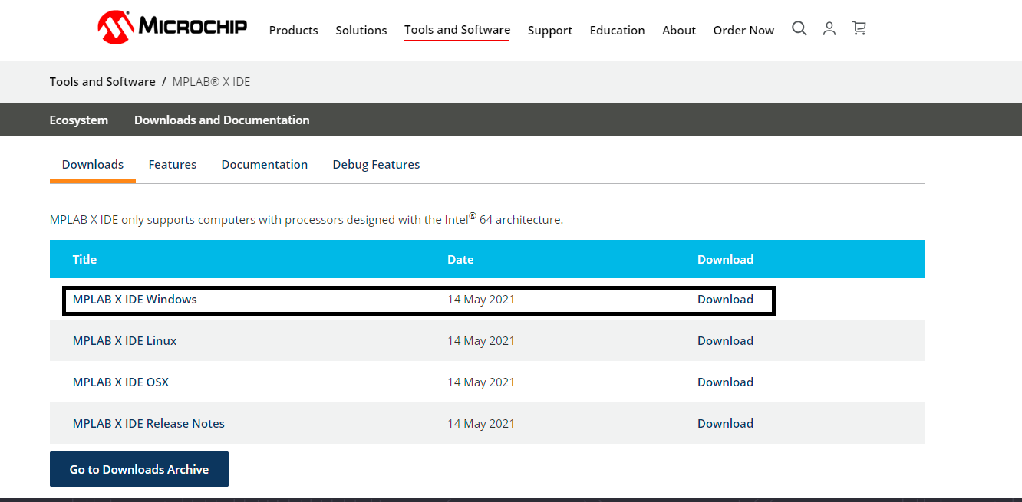

Step 2: Follow The Installation Steps. Click on downloaded MPLAB setup to install. Click on Next.

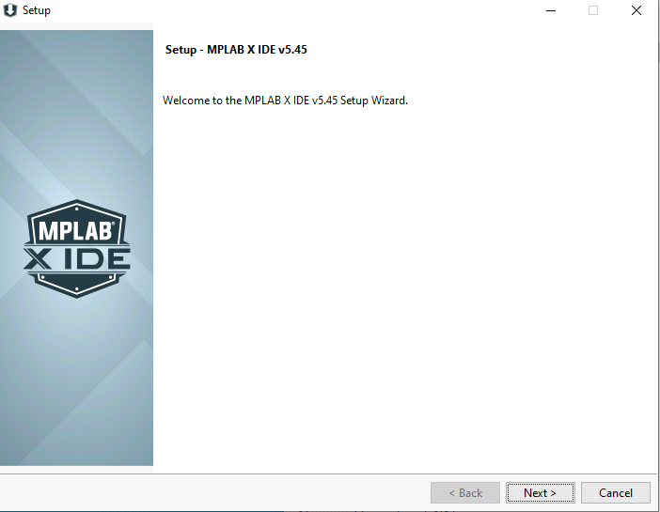

Step 3: Directory will set automatically to C:\Program Files\Microchip\MPLAB\ver no.

Select No Proxy (for the system without Internet Proxy settings). Click Next.

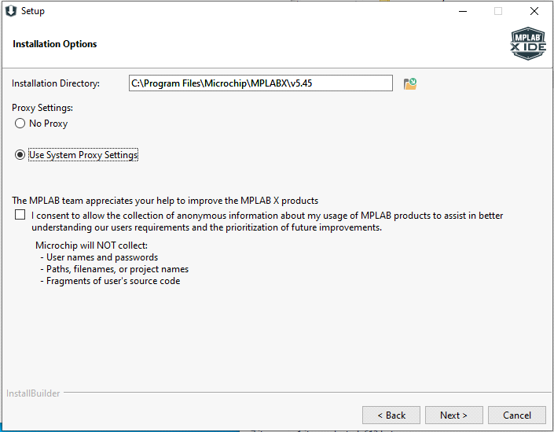

Step 4: Select MPLAB IDE and IPE is not required for development purposes you can install it if you want to explore. Select relevent option based on MCU bits you going to use.

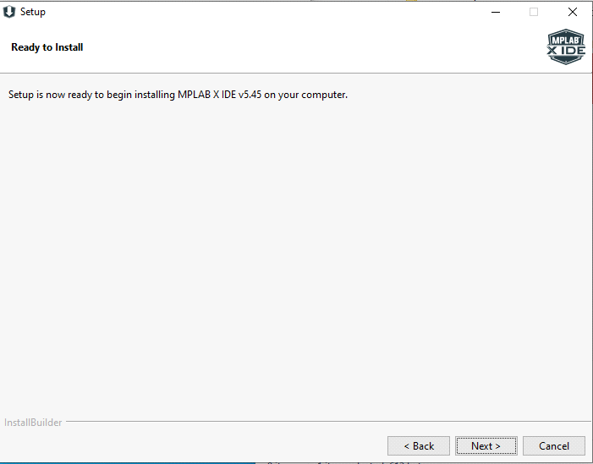

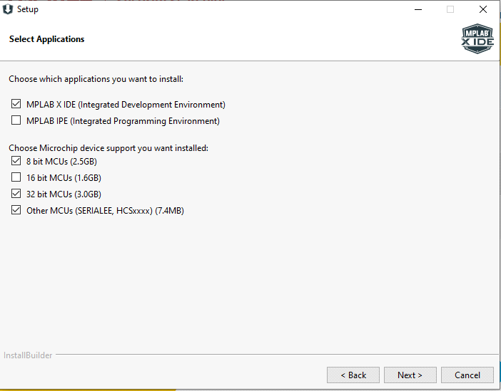

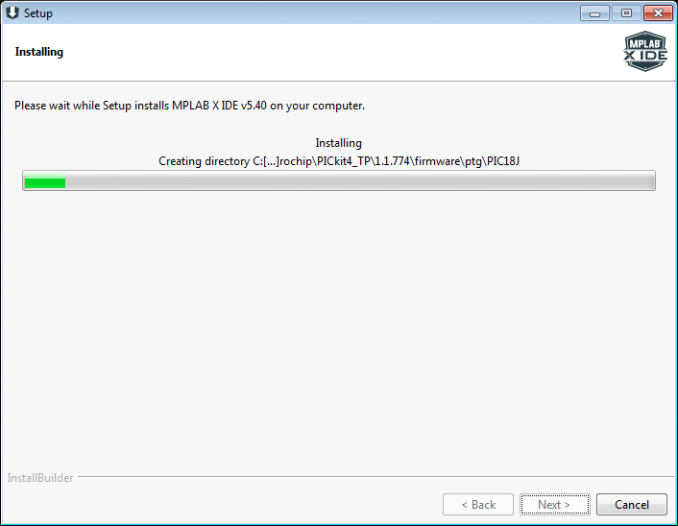

Step 5: Device driver pop up window will open if relevent drivers are not installed in your PC/Laptop. Install them.

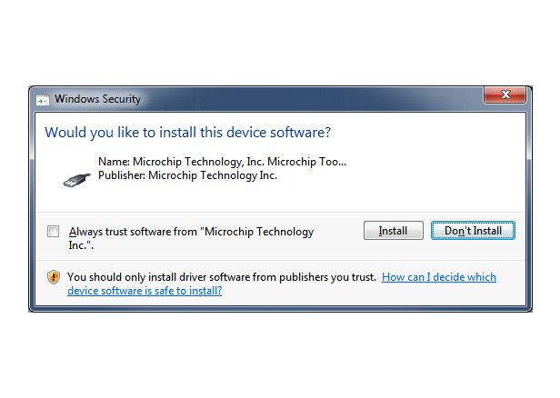

MPLAB IDE Installtion window will open, click on finish button.

**We need to download plugins for MPLAB IDE, for SAMD21 Curiosity Nano board MPLAB Harmony v3 Configurator need to be installed.**

**Below are the steps for MPLAB Harmony v3 Configurator.**

Step 1: Open MPLAB IDE

Step 2: Click on Tools -> Plugin Download. Click on MPLAB X Plugin Manager.

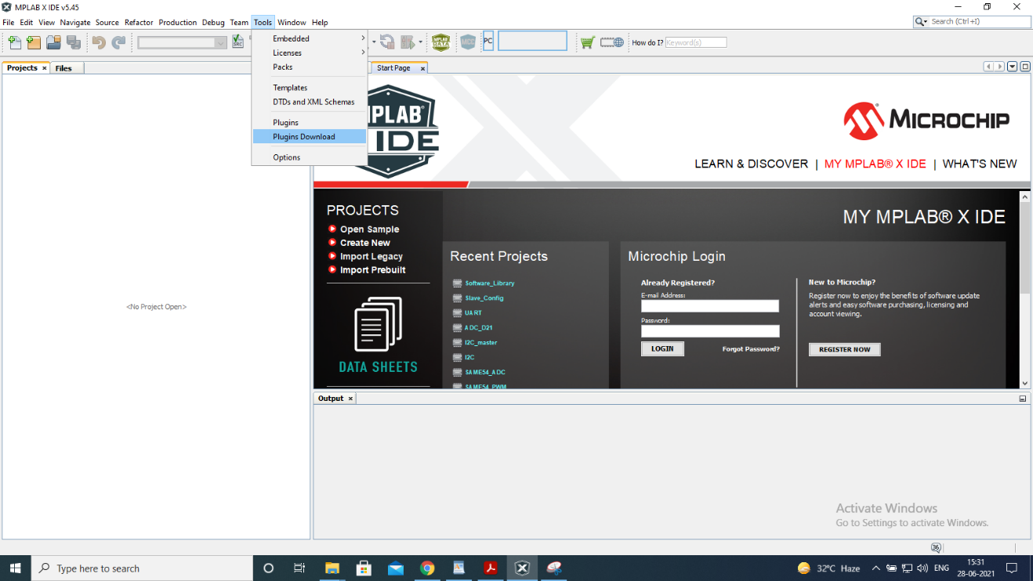

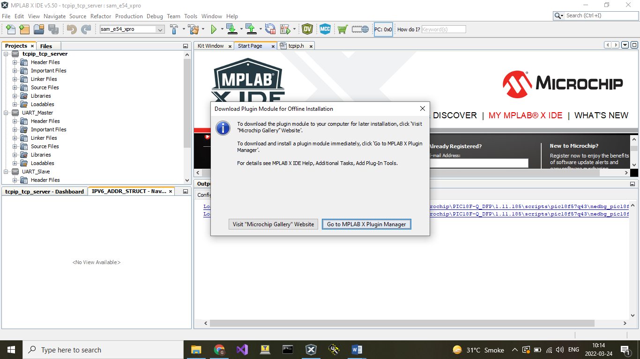

Step 3: Select "MPLAB Harmony3 Launcher" and "MPLAB Harmony Configurator".

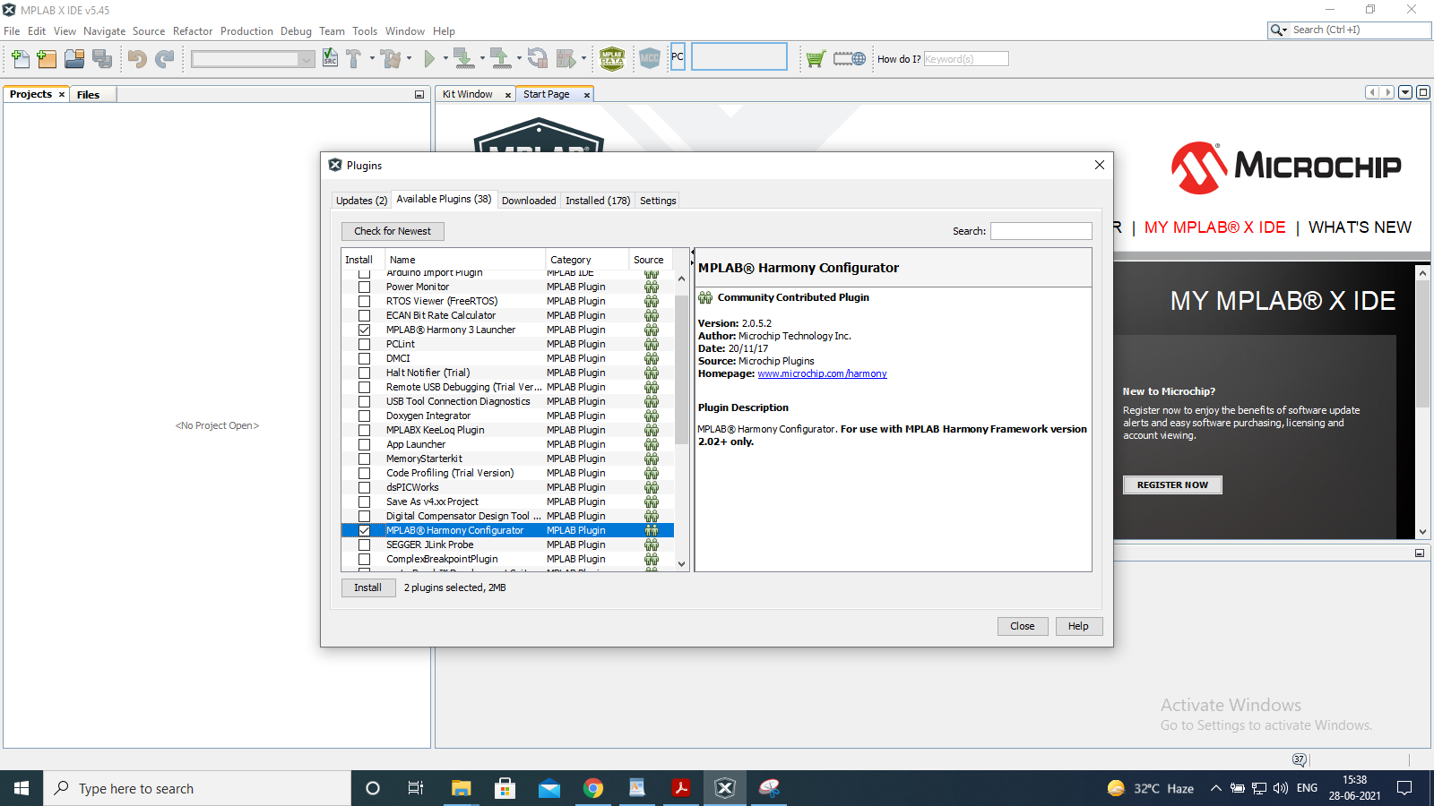

Step 4: Click on Install button placed on left bottom. Then click on Next.

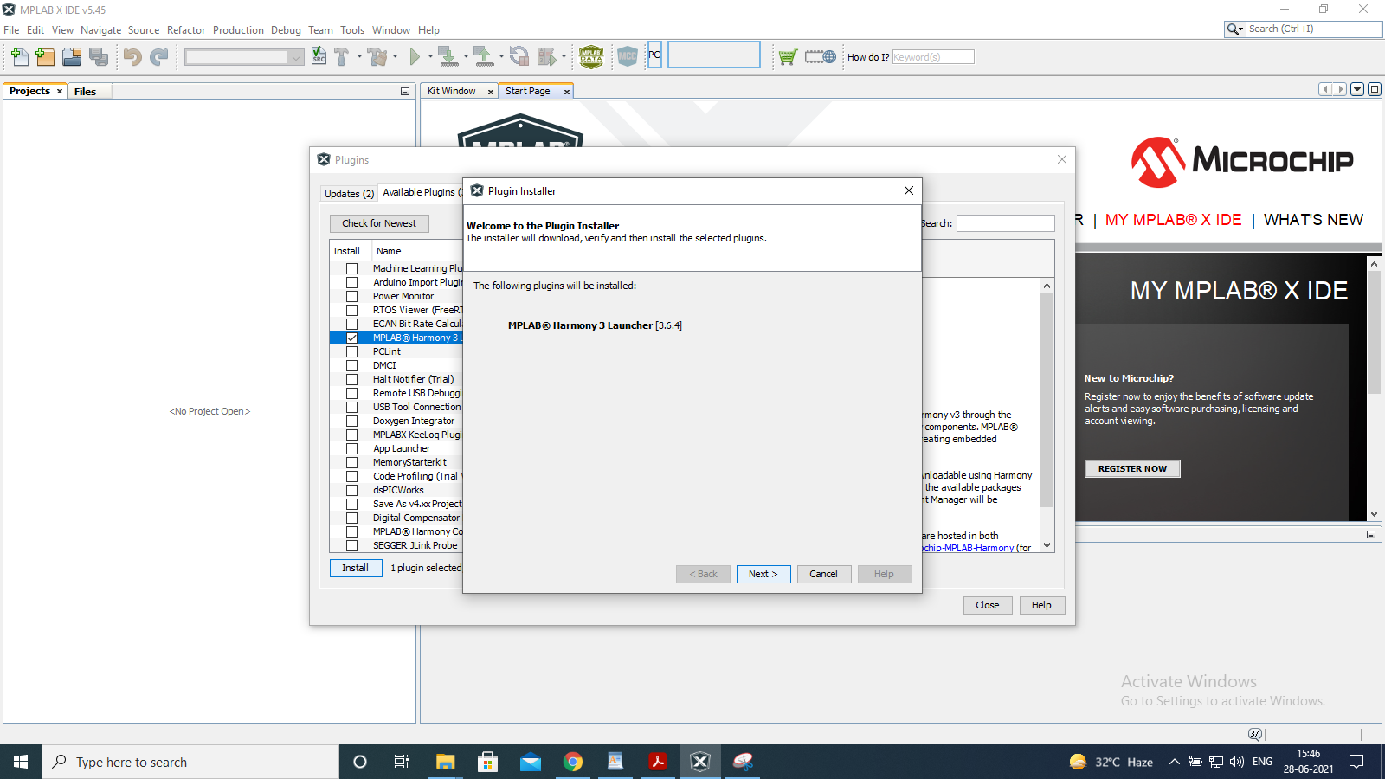

Step 5: Accept terms and conditions and click on install.

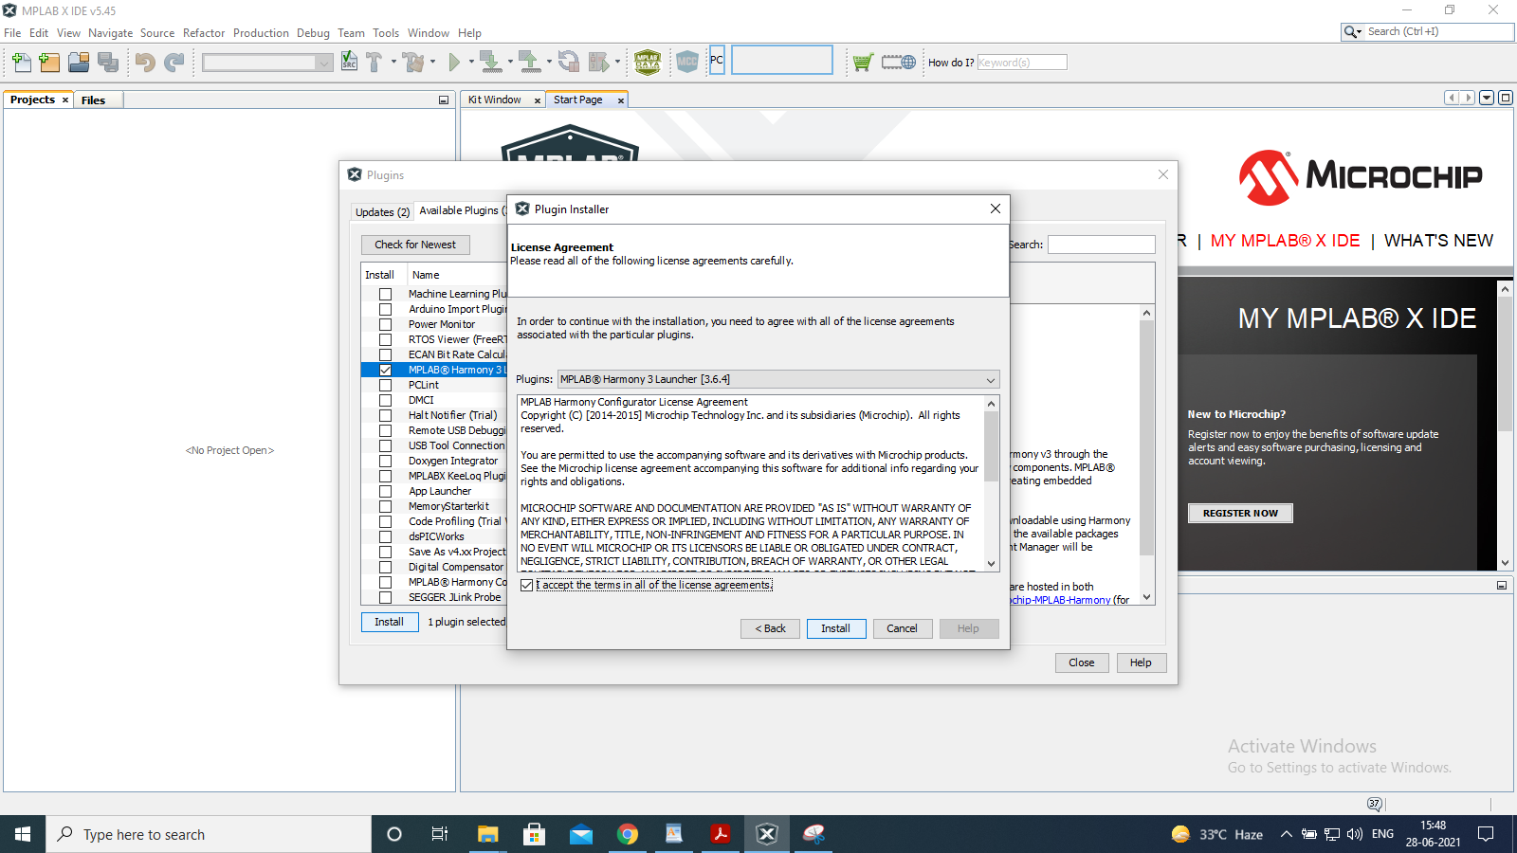

Step 6: Select Restart now and then Finish.

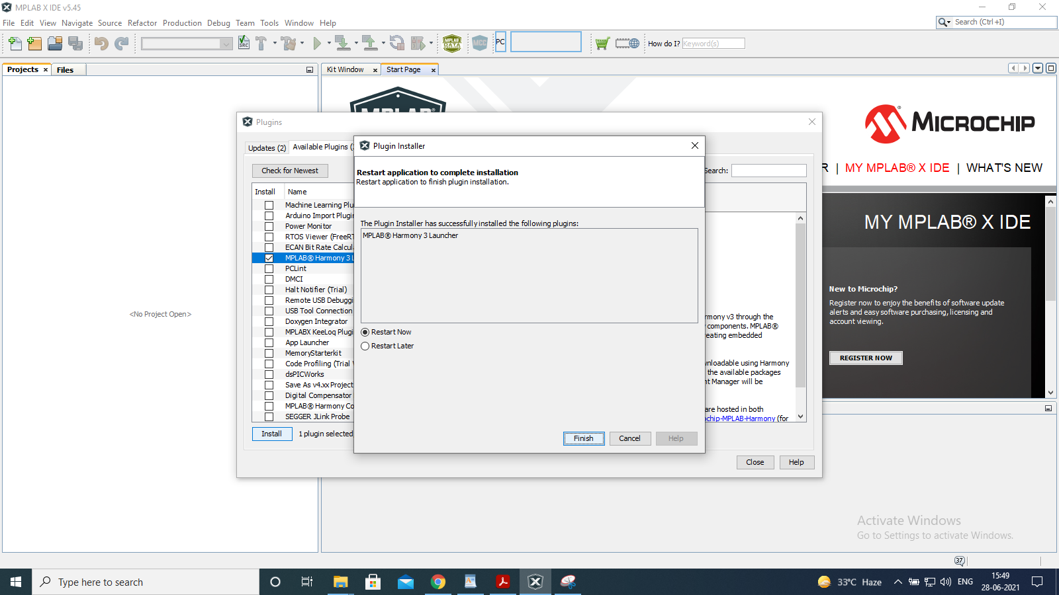

Step 7: Open MPLAB IDE ->Tools -> Embedded -> MPLAB Harmony 3 Content Manager.

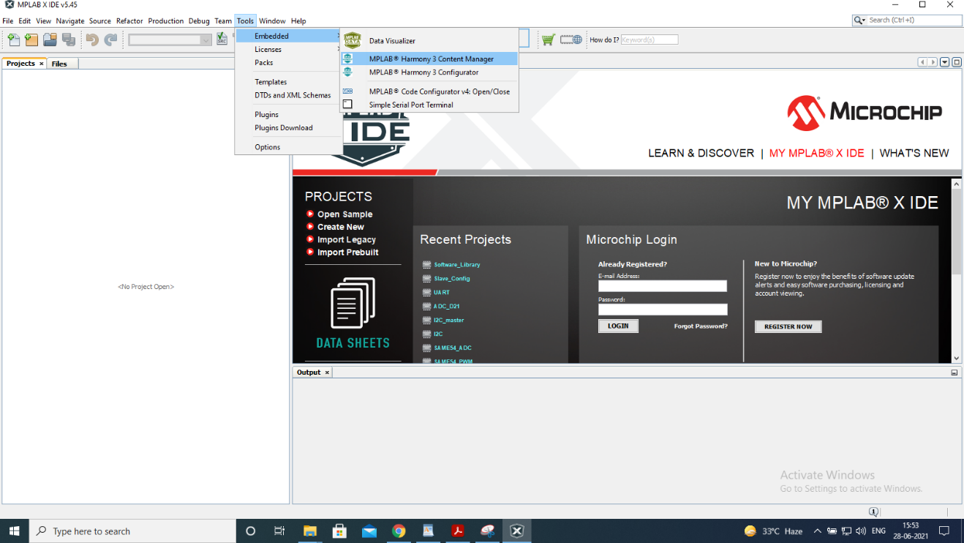

Step 8: Enter the Path and Remote URL and click on Next

Path: C:\User\XXX\Harmony3

URL: <https://github.com/Microchip-MPLAB-Harmony>

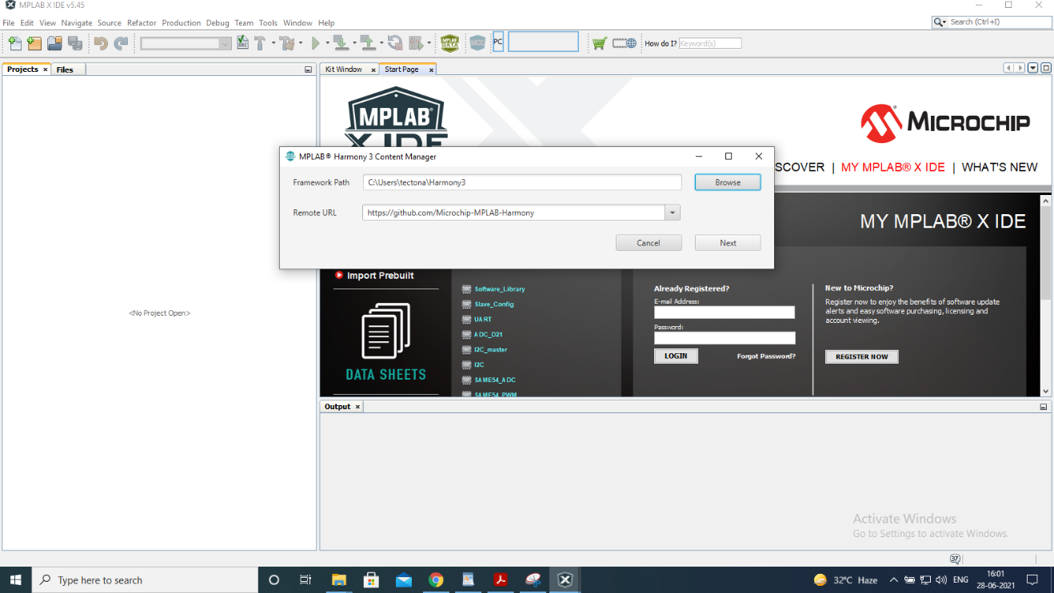

Step 9: Content Manager window will open. Select Packages: csp, mhc, dev_packs. Click

on Download selected.

**Compiler Installation**

Depending on your MCU, download the compiler accordingly (If your MCU is 32 bit then install XC32 compiler). You can get device information from your device datasheet/ user guide document.

Below guide for XC32 is given. Process for XC8 and XC16 will be the same.

**XC32 Compiler Installation Guide**

Step 1: Download XC32 Compiler from below link:

<https://www.microchip.com/en-us/development-tools-tools-and-software/mplab-xc-compilers#Downloads>

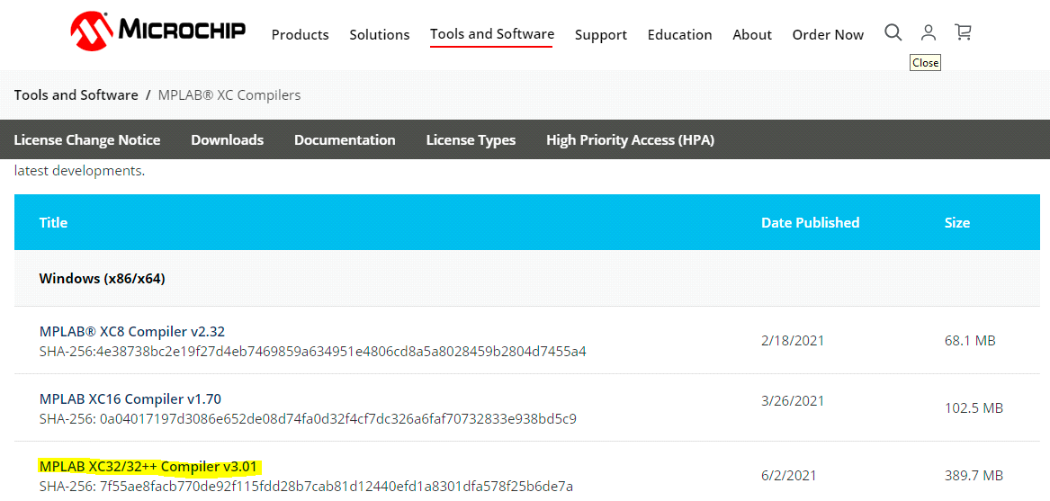

Step 2: Open downloaded file to start installation. Click on next.

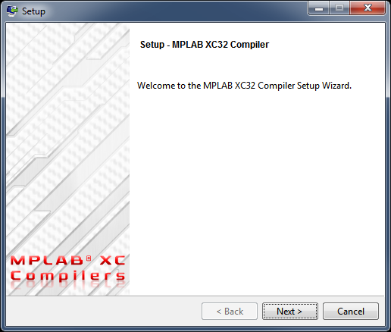

Step 3: Click on accept agreement and next.

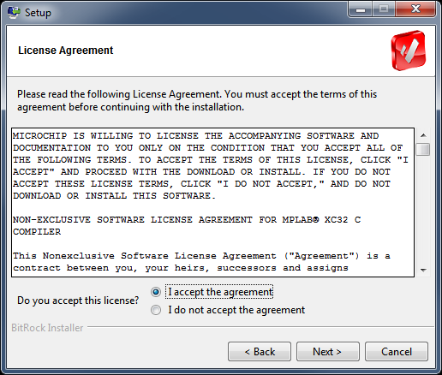

Step 4: Click on Next.

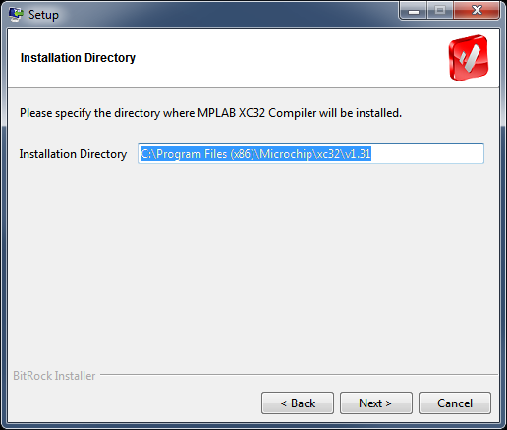

Step 5: Click on Next.

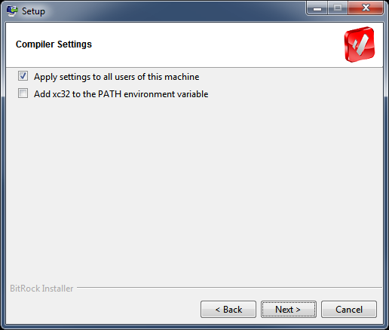

Step 6: Installation will start after that.

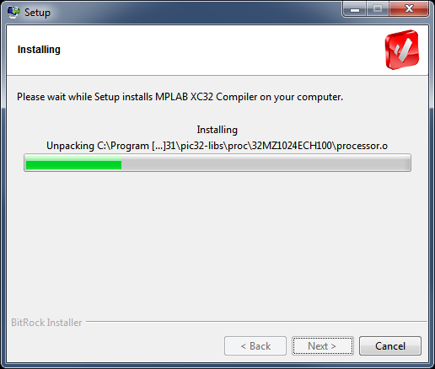

Step 7: Click on finish button. XC32 Compiler is installed.

